**SVR ENGINEERING COLLEGE**

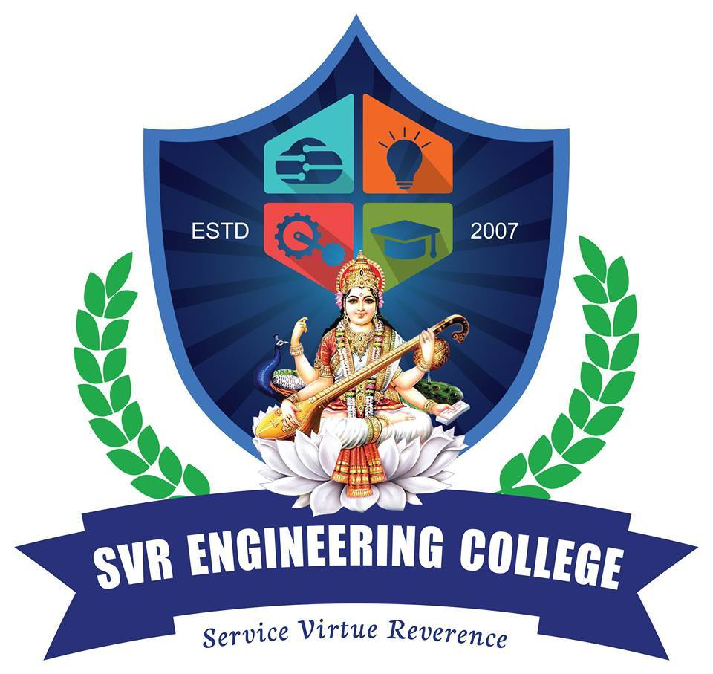

Towards Excellence in Higher Education

(approved by AICTE, New Delhi and Affliated to JNTUA , Anantapuramu.)

Ayyalur Metta, Nandyal – 518502, Kurnool (Dt),A.P.Cell : 9704468777 , 9100077771

**COURSE COMPLETION CERTIFICATE**

**SI.NO. sn Date : dt**

Certified that MR. /Miss Student name Roll No. rn

Son/Daughter of Sri Father name studied Number years B.Tech / MBA

M.Tech in Dept Department / Specialization in this Institute during dung . He / She has appeared for the Regular / Supplementary Examinations held in yr for which the results are expected in month .

This Certificate is issued at his / her request to enable him / her to apply for job / Higher Studies.

***Principal***